Experiment 6(a): Simulation and Performance Evaluation of People–Process–Data–Things IoE Framework using Edge/Fog-to-Cloud Pipeline with MQTT and Node-RED
1. Objectives
- To model the People–Process–Data–Things (P-P-D-T) IoE framework.
- To simulate data transmission using MQTT and Node-RED.
- To implement Edge/Fog-to-Cloud data processing.
- To evaluate latency, throughput, and reliability.
- To compare the performance of Edge, Fog, and Cloud processing.
2. Software Required
- Node-RED
- Mosquitto MQTT Broker
3. Procedure
- Configure an Inject node to simulate RFID tag scans and pass the data to the User_details Function node.
- Process the tag ID, device ID, identification status, temperature, and latency.
- Publish the processed data to the MQTT topic ioe/device/scan.
- Use an MQTT Input node to receive the scan data and process it through the Tap_here Function node, representing Edge processing.
- Publish the processed data to ioe/device/cloud to represent forwarding to the Cloud layer.
- Receive the cloud data using an MQTT Input node and verify the output through the Debug node.
- Observe valid and unknown tag IDs, temperature readings, and latency values in the Debug panel.
Output Table:
S.No. | Output parameter | Observed output
1 | RFID tag identification | Valid and unknown tag IDs
2 | MQTT topic | ioe/device/scan
3 | Edge processing | Data processed using Tap_here
4 | Cloud transmission | ioe/device/cloud
5 | Temperature | Approximately 29–31 °C in the displayed examples
6 | Latency | Approximately 2–4 ms in the displayed examples
7 | End-to-end data flow | Scan → Edge → Cloud → Debug

Output:
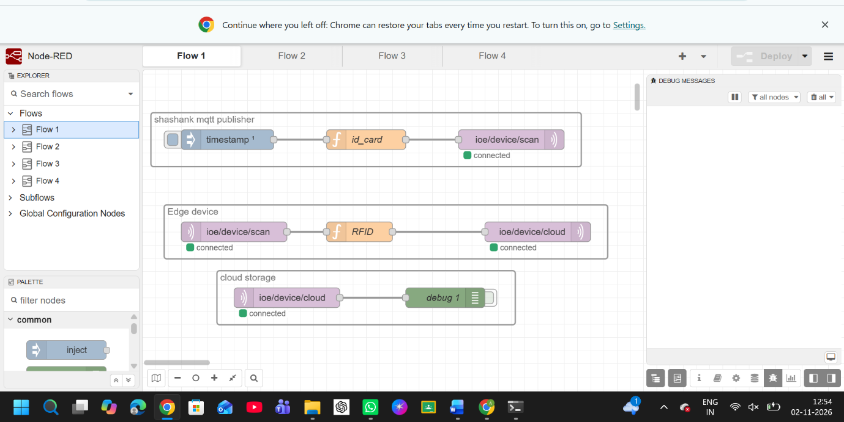
Result
The P-P-D-T IoE framework and Edge/Fog-to-Cloud pipeline were modelled using Node-RED and MQTT. The performance indicators were evaluated to compare different processing placements.

